Review Leo Janssen Premiere The Wanderings of Little Nell / The Old Curiosity Shop, Dickens Theatre Laren 10th november 2019

A Dickens novel in an afternoon
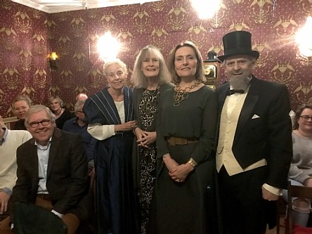

On the photo from left to right Else Flim, Emmy Strik, Alderman Karin van Hunnik and Adrian Kok
Nov. 11 -Sunday afternoon there was a more than excellent 'marathon show' in the Dickenstheater on the PC van den Brinkweg in which a 4-hour premiere -two intermissions- of the Dickens reading with Laterna Magica (magic lantern): The Old Curiosity Shop, in an adaptation of dramaturge Else Flim entitled The wanderings of Little Nell and brought by actor Adrian Kok. The show will be played once again this month.
It only increases admiration for this Laren couple who have 'pledged' their heart and soul to the great Victorian writer. Reducing the adaptation of the original novel, which has 715 pages (in small print!) to 48 A4 pages, is certainly no easy task, since Dickens lets something happen in almost every sentence of his novels. It’s an excellent achievement that Flim's adaptation has had no effect whatsoever on the atmosphere that Dickens manages to evoke in his books. (While everyone was pretty much puffing on the beach last summer, I heard that Else Flim - with a somewhat cooling fan - has been busy for months with Dickens' fourth novel). Charles Dickens’s The Old Curiosity Shop, appeared as a serial in his own weekly magazine Master Humphrey’s Clock. The first issue came out on April 4, 1840. The show tells the story of thirteen-year-old Nelly Trent and her grandfather, the somewhat demented owner of the London antique shop mentioned in the title. The old man regularly borrows considerable sums of money from the sinister dwarfish lender and slum-landlord Daniel Quilp. With this money he visits gambling dens at night where he gambles with cards. The profit is intended for his beloved only granddaughter, but of course he keeps losing.
All this leads to all kinds of complications whilst Dickens novels are interwoven with "cliffhangers" so that the story always remains exciting.
Above all, must be mentioned the acting performance of Adrian Kok who puts down an excellent Dickens. Given the enthusiasm and applause of the audience, it was a special afternoon in the smallest theatre in Laren. It was also special that the Alderman of Culture Karin van Hunnik was present and Emmy Strik the initiator of the Deventer Dickens Festival and founder / director of the Dickens cabinet in Deventer.
During the breaks blog writer Josephine was present with her new book : Around the table with Charles Dickens, domestic recipes from the nineteenth century. (www.myinnervictorian.nl)
November 17th is the second and last show of The wanderings of Little Nell. In the Dickenstheater. For more information http://www.dickenstheater.nl Go and see, run!
Sunday 15 and Sunday 22 and Thursday 26 December (Boxing Day) 2019, starting at 2 p.m. Dickenstheater Laren, with The friendly waiter and I from David Copperfield and of course Scrooge from A Christmas Carol. Admission € 15.00 incl. Coffee, tea, soda during the break. Reserve seats via: dickens@ziggo.nl or 035 8872376
(Review by Leo Janssen. Leo Janssen was former Alderman for Culture and the creative director of Endemol Television, created more than 60 television programs, he is an author and publisher and he staged cultural events like the Weihnachtsoratorium and the Matthäus Passion.)

